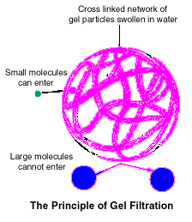
EXERCISE 4
SEPARATION OF PROTEINS
AND OTHER MOLECULES BY GEL FILTRATION

Introduction

Gel filtration became an established laboratory technique with the introduction of Sephadex in 1959. Since then, use of gel filtration in biochemistry laboratories has increased steadily both for analytical studies and preparative procedures. Separation by gel filtration is based on the molecular sieving action of tiny, porous beads. These beads consist of woven polymeric molecules (in the case of Sephadex; polydextran). When they are packed into a column, they form a complex filtration system. This method is particularly useful in separating proteins from each other as well as from ions (desalting) and small molecules.
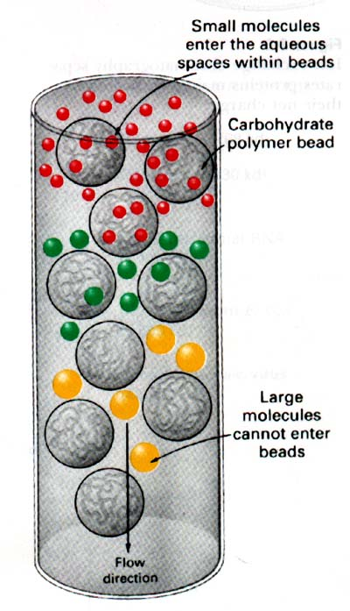
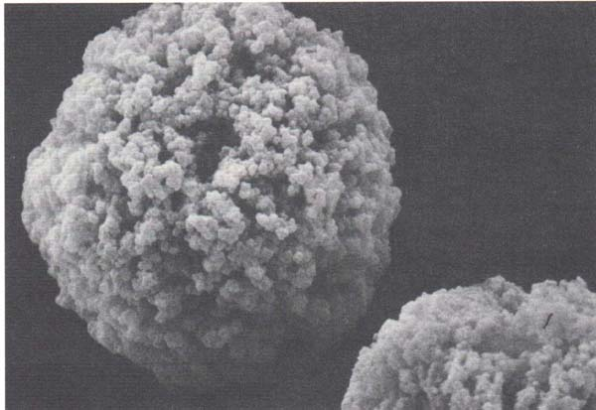 A gel filtration experiment can be schematically described as follows: Molecules bigger than the largest pores of the swollen gel-exclusion bead (i.e. these molecules are above the exclusion limit) can not penetrate the gel particle and therefore pass through the bed in the liquid (mobile) phase outside the particles (the matrix). Thus, the largest particles are eluted first. Molecules smaller than the exclusion limit, however, penetrate the gel particles to varying degrees, depending on their size and shape. Molecules are therefore eluted from the gel bed in order of decreasing molecular size. Estimation of the size of a molecule can be made using a standard curve of molecular weight (using a log10 scale) versus elution volume of several known standards that have been passed through the same column.
Fig. 4-1 An electron micrograph of a Sephadex particle
Gel particles are available in a variety of pore (sieve) sizes and are categorized based on the smallest molecule that can be excluded from the pores. The "fractionation range" is the span of particle sizes that can be separated using a given type of gel. Sieve sizes range from 102 to 107 daltons, so it is possible to choose a very specific range of exclusions for particle separation (see Figs 4-1, 4-2 and Table 4-1).

The objective of this exercise is to introduce students to the principles of gel-exclusion chromatography and specifically to apply these principles to achieving separation of the following colored compounds: blue dextran (mw 2,000,000), cytochrome c (red, mw 12,500), and potassium ferricyanide (K3Fe(CN)6, yellow, mw 329).

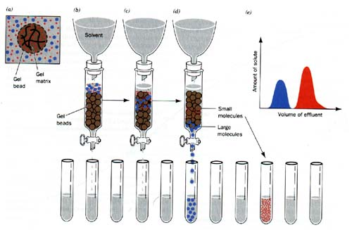
Figure 4-2. Characteristics of molecular exclusion gel materials and principles of molecular exclusion chromatography.
Properties of Sephadex® Gels
Sephadex® Gel | Exclusion size (MW) | MW Range (kDa)
G10 | 8 x 10³ | 0.4 - 6
G25 | 3 x 10⁴ | 0.8 - 20
G50 | 4 x 10⁴ | 2 -30
G75 | 6 x 10⁴ | 4 - 40
G100 | 1 x 10⁵ | 8 - 80
G150 | 2 x 10⁵ | 20 - 120
G200 | 5 x 10⁵ | 40 - 200
Table 4-1. Characteristics of Various Forms of Sephadex
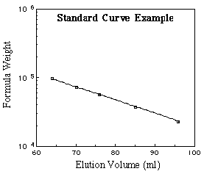

Figure 4-3. Plot of elution volume against log (mol.wt.) on a Sephadex column of a variety of biomolecules.

Materials and Methods

Materials
- chromatography column
- Sephadex G-50 (swollen in phosphate buffer (pH 7.5)
- separatory funnel
- ring stand and clamps
- blue dextran
- cytochrome c
- potassium ferricyanide (K3Fe(CN)6)
- eluent (phosphate buffer pH 7.5)
- 100 ml graduated cylinder
- test tubes numbered 1-40
- 250 ml beaker

Methods

Hydrating the Sephadex G-50 Beads (the instructor will prepare this ahead of time)

Appropriate quantities of dry Sephadex G-50 (1 g / 5ml of column) should be weighed and placed in a beaker. Eluent buffer should be mixed with the dry beads several hours before use to ensure complete hydration. If gel matrix is to be hydrated more than a few hours before use it should be refrigerated to limit bacterial growth.

Column Packing and Other Preparations (the instructor will pack the columns ahead of time to insure proper settling of the gel matrix)

Correct packing of the gel bed is of utmost importance to ensure optimal performance of all types of columns. Irregularities in packing give rise to uneven flow of the eluent buffer through the column (called channeling) which in turn may result in broadening.of bands.

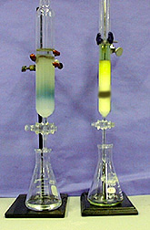 Setup the glass column vertically (a small level may aid proper mounting), with the stopcock closed and partially fill the column with eluent buffer. Next, excess buffer should be decanted from the equilibrated packing material (see above) until a thick slurry is formed. It should not be so thick as to retain air bubbles, however. The slurry should be swirled to disperse the gel beads. Next, carefully pour the slurry into the column, down either the column wall or a glass rod. Normally, it will not be possible to fill the column completely with gel matrix in one session. Allow the Sephadex beads to begin to settle; this will usually take a few minutes. Before the Sephadex beads have been completely packed, open the stopcock and allow some of the buffer to drain out (caution; never allow the column to become dry, since this will introduce air into the column and cause channeling). Swirl the remaining slurry as before and add it to the column. Again, allow the Sephadex beads to settle. Continue this process until the column is packed to the desired level (in this case about 1" from the top of the glass column). Because columns prepared in stages are often less well-packed, it is actually best to add an extension to the column so that enough slurry may be added to completely fill the column at one time. After the gel matrix has been added to the desired level (2-3 cm from the top of the column), leave approximately 1 cm of buffer above the top of the packed gel.

Carefully add a filter paper disk to the top of the packed column. Fill the separatory funnel with buffer and attach it to the ring stand. Obtain 40 test tubes from your instructor, and label them 1 through 40. In addition, pipet 2 mL of buffer into one test tube. Mark the tube at the 2 mL level; use this as a template to mark the other 40 test tubes at 2 mL.

Sample Application and Column Chromatography
Blue dextran, cytochrome c (red) and potassium ferricyanide (yellow) solutions have been prepared for you. Remove 100μL from each solution and mix all three together in a test tube (this will result in a brownish mixture). Next, open the column stopcock and allow the buffer to drain to the level of the gel bed (but not below). Carefully layer 200μL of the brown mixture onto the column, then open the stopcock and allow the sample to drain to the level of the gel bed. Next, add a few drops of buffer and allow it to drain into the column. Repeat this several times (be patient) until the brown mixture has passed into the column and you can see the white gel bed above the brown sample. Close the column stopcock. Gently layer buffer on top of the gel until it is about 1.5 cm from the top of the glass column. Place a beaker beneath the column to collect buffer. Open the stopcock on the separatory funnel and allow the eluent buffer to fill the tubing attached to it. Connect the separatory funnel to the column by placing the stopper firmly in the top of the glass column. Ensure that a tight seal exists, then open the outlet on the separatory funnel and lastly, open the stopcock on the glass column. As the eluent buffer drips into the column, the brown mixture should begin to separate into distinct blue, red and yellow bands. Continue to collect buffer in the beaker until the blue dextran band has migrated to the bottom of the column. Set the beaker aside; measure the volume of this buffer that has passed through the column and record this amount as the void volume. Continue to collect 2 mL fractions into separate test tubes without interruption until all the colored bands have been eluted from the column. Add 2 mL of buffer to each 2 mL sample and determine the absorbance of each tube using the Spectronic 20 at each of the following wavelengths: 440, 565, and 620 nm; these are the absorption maxima of ferricyanide, cytochrome c and blue dextran respectively.

Plot the results of the Spectronic 20 readings on one graph, with eluent volume (mL) as the independent variable (remember to include the void volume plus 2 mL for each tube you collected up to that fraction) and absorbance at each of the 3 wavelengths as the dependent variable. Also, describe your observations regarding the migration of the colored compounds through the column. Discuss the principle of gel filtration with respect to separation of these compounds. In addition, plot a second graph of elution volume on the y-axis versus log of molecular weight of each substance on the x-axis. This graph will be a standard curve that can be used for estimating molecular weight of samples separated on this column see fig 4-3.

